Final-project.R

brandonming

2021-04-11

#buliding the data frame  
rm(list = ls())  
A=rep(c(-1,1),4)  
B=rep(c(rep(-1,2),rep(1,2)),2)  
C=rep(c(rep(-1,4),rep(1,4)))  
  
#enter the data and complete the data frame.  
SpicyLevel=c(20,38,21,35,11,22,11,23,16,41,25,31,9,26,11,29)  
SpicyLevel_Data <- data.frame(SpicyLevel, A,B,C)  
  
#analysis the data   
res.lm<-lm(SpicyLevel~A*B*C, data=SpicyLevel_Data)  
summary(res.lm)

##   
## Call:  
## lm(formula = SpicyLevel ~ A * B * C, data = SpicyLevel_Data)  
##   
## Residuals:  
## Min 1Q Median 3Q Max   
## -3 -2 0 2 3   
##   
## Coefficients:  
## Estimate Std. Error t value Pr(>|t|)   
## (Intercept) 23.0625 0.6644 34.713 5.19e-10 ***  
## A 7.5625 0.6644 11.383 3.20e-06 ***  
## B 0.1875 0.6644 0.282 0.7849   
## C -5.3125 0.6644 -7.996 4.38e-05 ***  
## A:B -1.3125 0.6644 -1.976 0.0836 .   
## A:C -0.3125 0.6644 -0.470 0.6507   
## B:C 0.5625 0.6644 0.847 0.4218   
## A:B:C 1.5625 0.6644 2.352 0.0466 *   
## ---  
## Signif. codes: 0 '***' 0.001 '**' 0.01 '*' 0.05 '.' 0.1 ' ' 1  
##   
## Residual standard error: 2.658 on 8 degrees of freedom  
## Multiple R-squared: 0.9623, Adjusted R-squared: 0.9292   
## F-statistic: 29.14 on 7 and 8 DF, p-value: 4.41e-05

res.aov<-aov(SpicyLevel~A*B*C,data=SpicyLevel_Data)  
summary(res.aov)

## Df Sum Sq Mean Sq F value Pr(>F)   
## A 1 915.1 915.1 129.566 3.20e-06 ***  
## B 1 0.6 0.6 0.080 0.7849   
## C 1 451.6 451.6 63.938 4.38e-05 ***  
## A:B 1 27.6 27.6 3.903 0.0836 .   
## A:C 1 1.6 1.6 0.221 0.6507   
## B:C 1 5.1 5.1 0.717 0.4218   
## A:B:C 1 39.1 39.1 5.531 0.0466 *   
## Residuals 8 56.5 7.1   
## ---  
## Signif. codes: 0 '***' 0.001 '**' 0.01 '*' 0.05 '.' 0.1 ' ' 1

#Normal probability plot  
library(daewr)

## Registered S3 method overwritten by 'DoE.base':  
## method from   
## factorize.factor conf.design

fullnormal(coef(res.lm)[-1],alpha=.025)

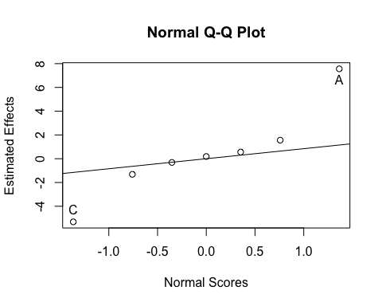

#Projected model  
res.aov<-aov(SpicyLevel~A*C,data=SpicyLevel_Data)  
summary(res.aov)

## Df Sum Sq Mean Sq F value Pr(>F)   
## A 1 915.1 915.1 85.287 8.40e-07 ***  
## C 1 451.6 451.6 42.087 2.99e-05 ***  
## A:C 1 1.6 1.6 0.146 0.709   
## Residuals 12 128.7 10.7   
## ---  
## Signif. codes: 0 '***' 0.001 '**' 0.01 '*' 0.05 '.' 0.1 ' ' 1

res.lm<-lm(SpicyLevel~A*C, data=SpicyLevel_Data)  
summary(res.lm)

##   
## Call:  
## lm(formula = SpicyLevel ~ A * C, data = SpicyLevel_Data)  
##   
## Residuals:  
## Min 1Q Median 3Q Max   
## -5.250 -1.625 0.500 1.188 4.750   
##   
## Coefficients:  
## Estimate Std. Error t value Pr(>|t|)   
## (Intercept) 23.0625 0.8189 28.163 2.49e-12 ***  
## A 7.5625 0.8189 9.235 8.40e-07 ***  
## C -5.3125 0.8189 -6.487 2.99e-05 ***  
## A:C -0.3125 0.8189 -0.382 0.709   
## ---  
## Signif. codes: 0 '***' 0.001 '**' 0.01 '*' 0.05 '.' 0.1 ' ' 1  
##   
## Residual standard error: 3.276 on 12 degrees of freedom  
## Multiple R-squared: 0.914, Adjusted R-squared: 0.8925   
## F-statistic: 42.51 on 3 and 12 DF, p-value: 1.143e-06

#Final model - remove non-significant terms  
res.lm<-lm(SpicyLevel~A*C-A:C, data=SpicyLevel_Data)  
summary(res.lm)

##   
## Call:  
## lm(formula = SpicyLevel ~ A * C - A:C, data = SpicyLevel_Data)  
##   
## Residuals:  
## Min 1Q Median 3Q Max   
## -4.9375 -1.4688 0.4375 1.1250 5.0625   
##   
## Coefficients:  
## Estimate Std. Error t value Pr(>|t|)   
## (Intercept) 23.0625 0.7915 29.137 3.16e-13 ***  
## A 7.5625 0.7915 9.554 3.05e-07 ***  
## C -5.3125 0.7915 -6.712 1.44e-05 ***  
## ---  
## Signif. codes: 0 '***' 0.001 '**' 0.01 '*' 0.05 '.' 0.1 ' ' 1  
##   
## Residual standard error: 3.166 on 13 degrees of freedom  
## Multiple R-squared: 0.9129, Adjusted R-squared: 0.8996   
## F-statistic: 68.17 on 2 and 13 DF, p-value: 1.284e-07

res.aov<-aov(SpicyLevel~A*C-A:C,data=SpicyLevel_Data)  
summary(res.aov)

## Df Sum Sq Mean Sq F value Pr(>F)   
## A 1 915.1 915.1 91.29 3.05e-07 ***  
## C 1 451.6 451.6 45.05 1.44e-05 ***  
## Residuals 13 130.3 10.0   
## ---  
## Signif. codes: 0 '***' 0.001 '**' 0.01 '*' 0.05 '.' 0.1 ' ' 1

#Residual Analysis  
#Normality  
SpicyLevel_residuals=res.aov$residuals  
qqnorm(SpicyLevel_residuals, ylim=c(min(SpicyLevel_residuals),max(SpicyLevel_residuals)), main = "Normal Q-Q Plot for Residuals",  
 xlab = "Theoretical Quantiles", ylab = "Sample Quantiles- Modified",  
 plot.it = TRUE, datax = FALSE)  
  
qqline(SpicyLevel_residuals, datax = FALSE, distribution = qnorm)

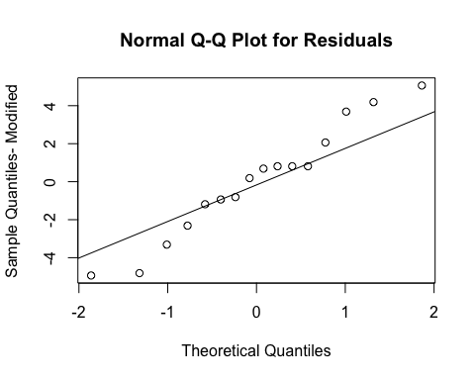

#Test normality using Shapiro Wilks  
shapiro.test(SpicyLevel_residuals)

##   
## Shapiro-Wilk normality test  
##   
## data: SpicyLevel_residuals  
## W = 0.96287, p-value = 0.714

#Check Variance  
Fitted_values=res.aov$fitted.values  
plot(Fitted_values,SpicyLevel_residuals,ylab="Residuals",xlab="Fitted Values")  
abline(h=0)

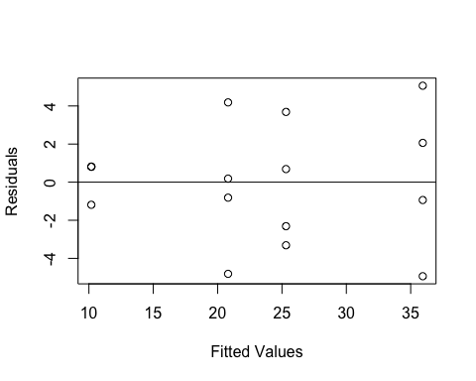

# Block design  
#Introducing Block effect  
#Modification 1- counfound ABCD with blocks  
Block1=c(1,2,1,2,2,1,1,2,2,1,1,1,2,2,1,2)  
#Modified response variable  
SpicyLevelRate_Mod=SpicyLevel;  
SpicyLevelRate_Mod[Block1==1]=SpicyLevelRate_Mod[Block1==1]-1  
SpicyLevelRate_Data_Mod <- data.frame(SpicyLevelRate_Mod, A,B,C)  
res.aov2<-aov(SpicyLevelRate_Mod~A*B*C+Block1,data=SpicyLevelRate_Data_Mod)  
summary(res.aov2)

## Df Sum Sq Mean Sq F value Pr(>F)   
## A 1 945.6 945.6 117.409 1.26e-05 ***  
## B 1 0.1 0.1 0.008 0.932269   
## C 1 430.6 430.6 53.462 0.000161 ***  
## Block1 1 0.8 0.8 0.101 0.760033   
## A:B 1 32.6 32.6 4.047 0.084162 .   
## A:C 1 1.6 1.6 0.194 0.672878   
## B:C 1 5.1 5.1 0.629 0.453897   
## A:B:C 1 33.3 33.3 4.141 0.081327 .   
## Residuals 7 56.4 8.1   
## ---  
## Signif. codes: 0 '***' 0.001 '**' 0.01 '*' 0.05 '.' 0.1 ' ' 1

res.lm2<-lm(SpicyLevelRate_Mod~A*B*C+Block1, data=SpicyLevelRate_Data_Mod)  
fullnormal(coef(res.lm2)[-1],alpha=.025)

